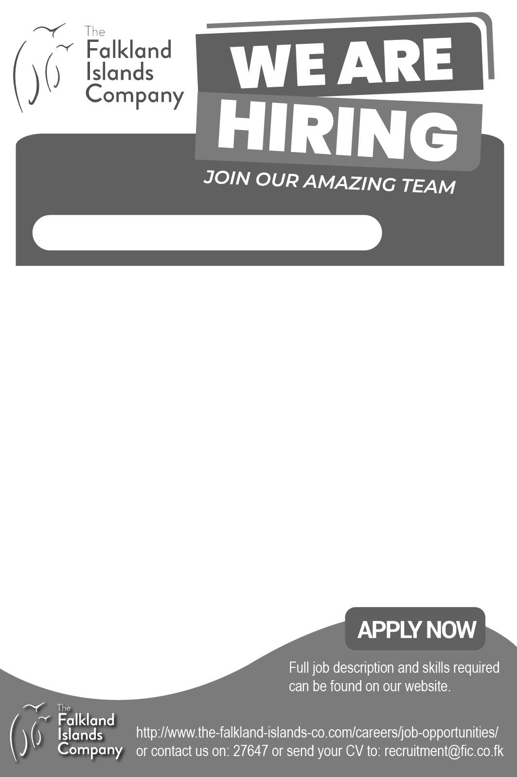

Penguin Travel Casual Opportunities

Penguin Travel is seeking enthusiastic and reliable individuals to join our team in a range of casual roles.

Tour Guides – Bertha’s Beach, Nature Trek, City Walking Tour, Stanley Highlights, Maritime History Walk or Battlefields.

Cruise Assistants – Tour Guides and Cruise Assistants must hold FITB Tour Guide Accreditation and a Level 3 First Aid Certificate.

Coach and Minibus Drivers – Applicants must hold a valid D/D1 driving licence and a Level 3 First Aid Certificate. Minibus drivers must also hold FITB Tour Guide Accreditation.

Cruise Rookies – Open to FICS students aged 14 years and over.

Cleaners

Please send your updated CV to penguintravel.manager@fic.co.fk, quoting:

“VHR0392 – [Role applied for]”

Closing Date: 14 August 2026

